**7.1 Understanding Psychological Disorders**

Biomedical vs Biopsychosocial Approaches

1. Biomedical approach
   1. Takes into account only the physical and **medical** causes of a psychological disorder
   2. Thus treatments in this approach are of biomedical nature
2. Biopsychosocial approach
   1. Considers the relative contributions of **biological** (e.g. genetic syndrome), **psychological** (individual’s thoughts) and **social** (e.g. discrimination) components to an individual’s disorder

Classifying Psychological Disorders

* The *Diagnostic and Statistical Manual of Mental Disorders* is used to diagnose psychological disorders
  + Categorizes mental disorders based on symptom patterns

Rates of Psychological Disorders

* In America, from highest to lowest:
  + Specific phobia, social anxiety disorder, major depressive disorder, alcohol use disorder, posttraumatic stress disorder, etc

**7.2 Types of Psychological Disorders\***

Schizophrenia

* Prototypical disorder with psychosis as a feature
* Can be treated using neuroleptics (an antipsychotic drug) which are effective in treating positive symptoms, but side effects include cognitive dulling, which can exacerbate negative symptoms

1. Positive symptoms
   * + Add something to behaviour, cognition, or affect
     + Include **delusions, hallucinations**, disorganized speech, and disorganized behavior
2. Negative symptoms
   * + The loss of something from behavior, **cognition**, or affect e.g. **dulled emotions**
     + Include disturbances of affect and avolition

Depressive Disorders

1. Major depressive disorder
   1. Contains at least one major depressive episode (for at least 2 weeks with at least 5 symptoms)
   2. Does not have manic episodes
2. Persistent depressive disorder
   1. Is dysthymia for at least two years that does not meet criteria for major depressive disorder
3. Seasonal affective disorder
   1. Colloquial name for major depressive disorder with seasonal onset, with depression occurring during winter months
   2. Treated with bright light therapy

Bipolar and Related Disorders

* Formerly known as manic depression, characterized by depression and mania
* Mania episodes are characterized by abnormal and elevated moods lasting at least one week with at least three of the symptoms

1. Bipolar I disorder
   1. Contains at least one manic episode
2. Bipolar II disorder
   1. Contains at least one hypomanic episode and at least one major depressive episode
3. Cyclothymic disorder
   1. Contains hypomanic episodes with dysthymia

Anxiety Disorders

1. Generalized anxiety disorder
   1. Disproportionate and persistent worry about **many different things** for at least six months e.g. making mortgage payments, doing a good job at work, etc
2. Specific phobias
   1. Irrational fears of **specific** objects or situations
3. Social anxiety disorder
   1. Anxiety due to social or **performance** situation
4. Agoraphobia
   1. Fear of places and situations where it is **hard for an individual to escape**
5. Panic disorder
   1. Marked by **recurrent panic attacks**: intense, overwhelming fear and sympathetic nervous system activity with no clear stimulus
   2. May lead to agoraphobia

Obsessive-Compulsive and Related Disorders

1. Obsessive-Compulsive Disorder characterized by:
   1. Obsessions (persistent, intrusive thoughts and impulses that **raise stress level**)
   2. Compulsions (repetitive tasks that **relieve tension** but cause significant impairment in a person’s life)
2. Body Dysmorphic Disorder
   1. A person has an unrealistic negative evaluation of his or her personal **appearance** and attractiveness, usually directed toward a certain body part
   2. Individual often takes extreme measures e.g. plastic surgery to correct the perceived imperfection

Trauma- and Stressor- Related Disorders

1. Post-traumatic stress disorder (PTSD) is characterized by:
   1. Intrusion symptoms (reliving the event, flashbacks, nightmares)
   2. Avoidance symptoms (avoidance of people, places, objects associated with trauma)
   3. Negative cognitive symptoms (amnesia, negative mood and emotions)
   4. Arousal symptoms (increased startle response, irritability, anxiety)
2. Called **acute stress disorder** if the same symptoms last for less than one month (but more than three days)

Dissociative Disorders

* The person avoids stress by escaping from his identity, who otherwise still has an intact sense of identity

1. Dissociative Amnesia
   1. **Inability to recall past experiences**
   2. In more severe forms, the person may experience dissociative fugue:
      1. A sudden, unexpected move or purposeless wandering away from one’s home or location of usual daily activities
      2. Confused about their identity and can even assume a new identity
2. Dissociative Identity Disorder
   1. Occurrence of **two or more personalities** that take control of a person’s behaviour
3. Depersonalization/ Derealization Disorder
   1. Involves feelings of **detachment** from the mind and body or from the environment

Somatic Symptom and Related Disorders

1. Somatic symptom disorder
   1. Involves **at least one somatic symptom**, which may or may not be linked to an underlying medical condition, which causes **disproportionate concern**
2. Illness anxiety disorder
   1. **Preoccupation with thoughts** about having, or coming down with a serious medical condition
   2. E.g. Thinking that you might have accidentally contracted HIV
3. Conversion disorder
   1. Involves **unexplained symptoms** affecting motor or sensory function and is **associated with prior trauma**
   2. E.g. A mother going blind shortly after watching her son die tragically

Personality Disorders

* Patterns of inflexible, **maladaptive** behavior that cause distress or impaired functioning in at least two of the following: cognition, emotions, interpersonal functioning, or impulse control
* Occur in three clusters:
  + Cluster A - “Weird” (Odd or eccentric)
    - Paranoid personality disorder
      * Distrust and suspect others’ motives
    - Schizoid personality disorder
      * Detached from social relationships
      * Restricted range of emotions
    - Schizotypal personality disorder
      * May have ideas of reference, magical thinking e.g. superstitiousness or a belief in clairvoyance
  + Cluster B - “Wild” (Dramatic, emotional, or erratic)
    - Antisocial personality disorder
      * A pattern of disregard for and violation of the rights of others
      * Repeated illegal acts, or show no remorse
    - Borderline personality disorder
      * Pervasive instability in interpersonal behavior, mood and self-image
      * May use splitting as a defense mechanism (view others as either ALL GOOD or ALL BAD)
    - Histrionic personality disorder
      * Characterized by constant attention-seeking behavior
      * Often wear colorful clothing, are dramatic and are exceptionally extroverted
      * May also use seductive behavior to gain attention
    - Narcissistic personality disorder
      * Has a grandiose sense of self-importance or uniqueness, a need for constant admiration and attention, etc
      * Have very fragile self-esteem and are constantly concerned with how others view them
  + Cluster C - “Worried” (Anxious or fearful)
    - Avoidant personality disorder
      * The affected individual has extreme shyness and fear of rejection
      * See herself as socially inept and is often socially isolated
    - Dependent personality disorder
      * Characterized by a continuous need for reassurance
      * Tend to remain dependent on one specific person eg. parent to take actions and make decisions
    - Obsessive-compulsive personality disorder (OCPD)
      * Individual is a perfectionist and inflexible, tending to like rules and order

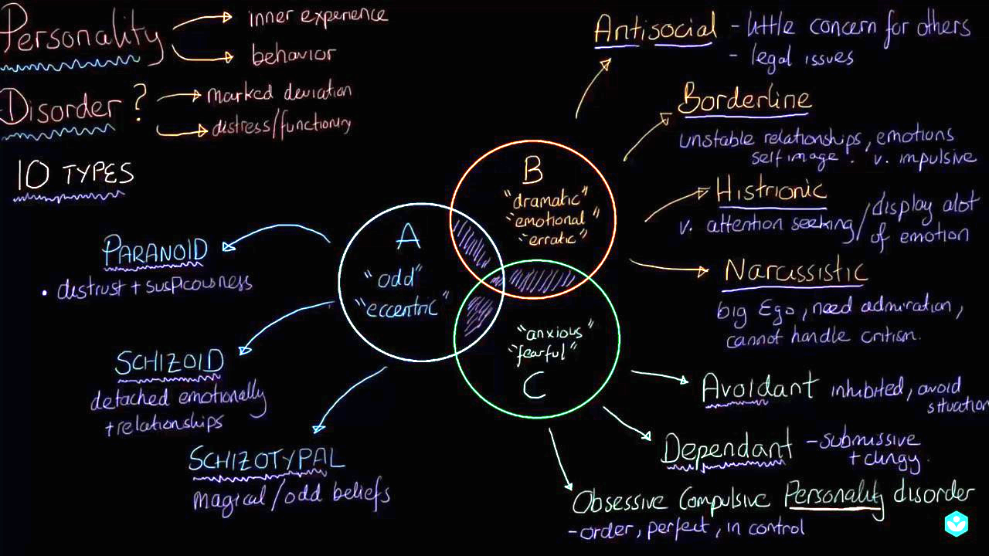

**7.3 Biological Basis of Nervous System Disorders**

Schizophrenia

* May be associated with genetic factors, birth trauma, adolescent marijuana use, and family history
* **High levels of dopaminergic transmission**

Depressive Disorders

* Abnormally high glucose metabolism in the amygdala
* Hippocampal atrophy after a long duration of illness
* Abnormally high levels of glucocorticoids (cortisol)
* Decreased epinephrine, serotonin, and dopamine (monoamine theory)
  + Production decreases; not that production stays the same and degradation increases

Bipolar Disorders

* Increased norepinephrine and serotonin (monoamine theory)
* Higher risk if parent has bipolar disorder
* Higher risk for persons with multiple sclerosis

Alzheimer’s Disease

* A type of dementia characterized by **gradual memory loss**, disorientation to time and place, problems with abstract thought, and a tendency to misplace things
* Later stages are associated with changes in mood or behavior, changes in personality, difficulty with procedural memory, poor judgment, and loss of initiative
* Disease is associated with genetic factors, brain atrophy, **decreases in acetylcholine, senile plagues of β-amyloid, and neurofibrillary tangles of hyperphosphorylated tau protein**

Parkinson’s Disease

* Characterized by:
  + Bradykinesia (slowness in movement)
  + Resting tremor (a tremor that appears when muscles are not being used)
  + Pill-rolling tremor (like rolling a pill with your thumb and fingers)
  + Mask-like facies (a facial expression consisting of static and expressionless facial features, staring eyes, and a partially open mouth)
  + Cogwheel rigidity (muscle tension that intermittently halts movement as an examiner attempts to manipulate a limb)
  + Shuffling gait (with stooped posture)
* There is **decreased production of dopamine** by cells in the substantia nigra
* Condition can be managed with **L-DOPA**, a precursor that is converted to dopamine once in the brain